TRATAMIENTO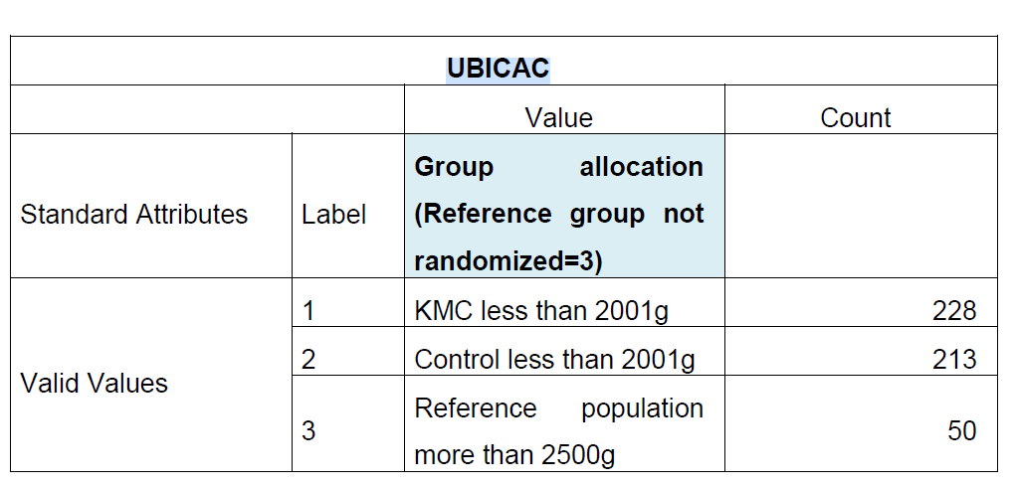

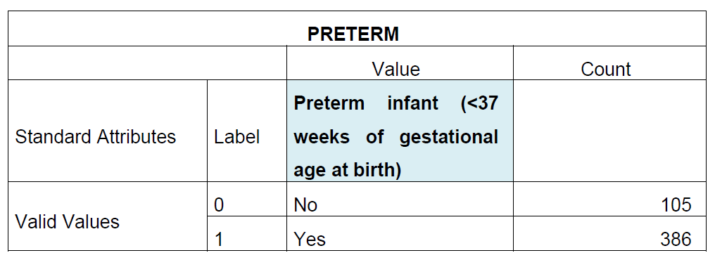

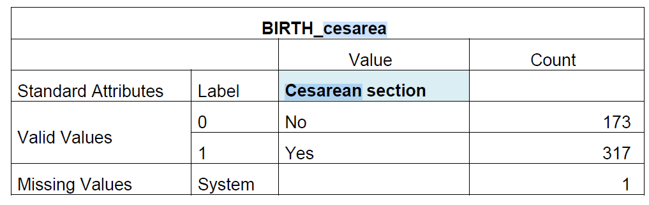

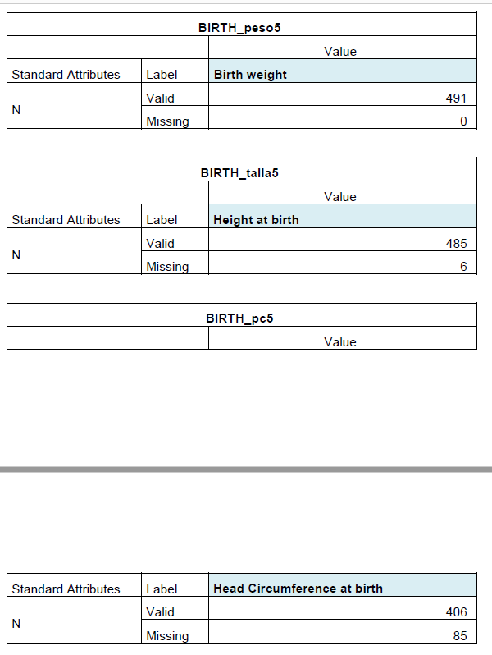

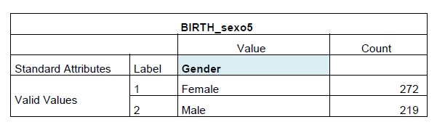

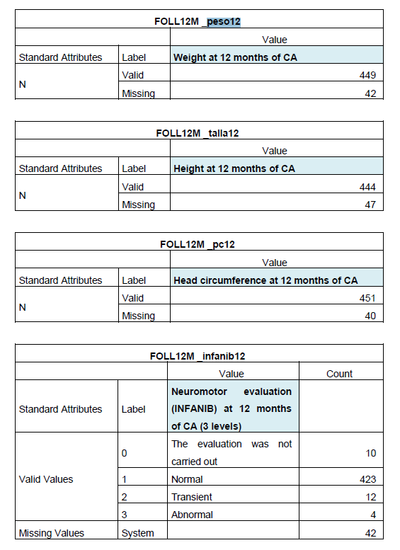

Masa blanca cerebelo

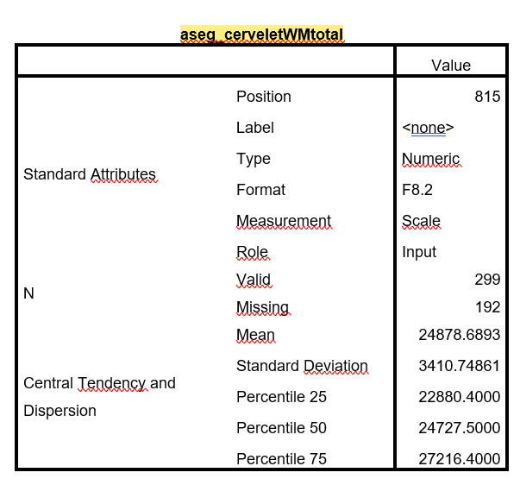

Masa Gris Cerebelo

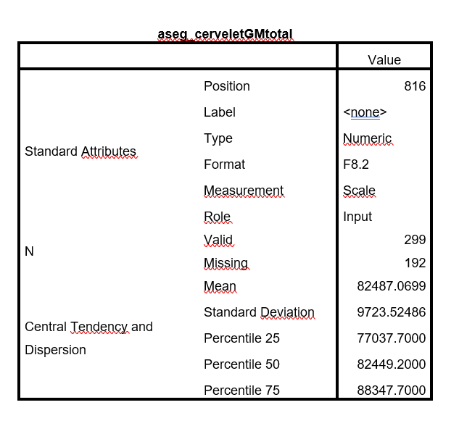

|  |  |  |
| --- | --- | --- |
| **aseg_hipocampototal (Volumen Hipocampo)** | | |
|  | | Value |
| Standard Attributes | Position | 819 |
| Label | <none> |
| Type | Numeric |
| Format | F8.2 |
| Measurement | Scale |
| Role | Input |
| N | Valid | 299 |
| Missing | 192 |
| Central Tendency and Dispersion | Mean | 7368.4187 |
| Standard Deviation | 916.31109 |
| Percentile 25 | 6843.2000 |
| Percentile 50 | 7360.4000 |
| Percentile 75 | 8068.3000 |

|  |  |  |
| --- | --- | --- |
| **aseg_caudatetotal (Volumen total Caudado)** | | |
|  | | Value |
| Standard Attributes | Position | 820 |
| Label | <none> |
| Type | Numeric |
| Format | F8.2 |
| Measurement | Scale |
| Role | Input |
| N | Valid | 299 |
| Missing | 192 |
| Central Tendency and Dispersion | Mean | 7197.1358 |
| Standard Deviation | 1009.79002 |
| Percentile 25 | 6585.5000 |
| Percentile 50 | 7212.8000 |
| Percentile 75 | 7840.7000 |

|  |  |  |
| --- | --- | --- |
| **aseg_putamentotal (Volumen Putamen)** | | |
|  | | Value |
| Standard Attributes | Position | 821 |
| Label | <none> |
| Type | Numeric |
| Format | F8.2 |
| Measurement | Scale |
| Role | Input |
| N | Valid | 299 |
| Missing | 192 |
| Central Tendency and Dispersion | Mean | 12322.4090 |
| Standard Deviation | 1428.00770 |
| Percentile 25 | 11279.9000 |
| Percentile 50 | 12232.6000 |
| Percentile 75 | 13384.9000 |

|  |  |  |
| --- | --- | --- |
| **aseg_amigdalatotal (Volumen Amigdala)** | | |
|  | | Value |
| Standard Attributes | Position | 822 |
| Label | <none> |
| Type | Numeric |
| Format | F8.2 |
| Measurement | Scale |
| Role | Input |
| N | Valid | 299 |
| Missing | 192 |
| Central Tendency and Dispersion | Mean | 3317.2977 |
| Standard Deviation | 498.86325 |
| Percentile 25 | 2988.8000 |
| Percentile 50 | 3312.8000 |
| Percentile 75 | 3642.7000 |